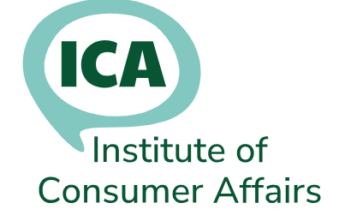
Annual Subscription Renewal

Please complete this form - even if your details haven’t changed, so we can keep our records up to date.
Tick here if you are paying by cheque (see 2a)
Tick here if you are paying by standing order (see 2b)
Tick here if you are paying by BACS (see 2c)
Tick here if you require a receipt

Title | Mr/Mrs/Ms/ Other (specify)
First Name(s)
Surname
Please tick the address to be used for correspondence
Home address: |  |  |  |  | Tick one
Job title:
Employer name and address: |  |  |  |  | Tick one
Home phone:
Office phone:
Mobile phone:
Please tick the email address to be used for icanews. You can use either or both
Home email:
Office email:
If your employer is to be invoiced, it is your responsibility to provide the following details so that we can issue the invoice
Order date: |  |  | Order No:
Contact Name: |  |  | Phone:
Contact email:
Organisation Name and Address for invoice:
If you have any questions, please contact: | Membership Secretary: membership@icanet.org.uk

Renewal Information

The membership year runs from 1 September to 31 August.

1a. If you joined after 1 June, you do not have to pay a renewal fee the following September.

1b. This membership renewal form must be completed and returned to the Membership Secretary, regardless of the renewal method, so we can keep your information up to date. For example, if you have forgotten to give us a change of email address, you will not be able to access the newsgroup.

- Renewal methods
2a. Cheque, made payable to: Institute of Consumer Affairs and send, with this form to:

ICA Membership
Corsletts Farm Church Road
Broadbridge Heath
Horsham
RH12 3LD
2b. Standing order. A mandate is available from the Membership Secretary on request. You must include your membership number as the reference; or we won’t be able to identify your payment.

2c. BACS: Sort code: 08-92-99
Account number: 65208449
Account Name: Institute of Consumer Affairs.
Reference: (Your name and membership number)

2d. Invoice. We can only invoice your employer if you provide details and a purchase order.

3. Fees and discounts - Annual membership fees:

Full member £25 (discounted to £20 if payment is received before 15 October or, if paid annually by standing order, on or before 30 September)
Unwaged £10

There are different forms for the following:

Training & Information Service (TIS)

£25 each for the first 5 members, £20 for each additional member (there is a separate form for multiple members at the same organisation)

Student There is no fee for applicants studying for a career in consumer affairs.

5. Reminders Renewal information will be posted on the newsgroup. You will also be sent an invoice. After two reminders, membership will be terminated for non-payment and you will be blocked from using the newsgroup.

6. Resignation If you don’t wish to renew, please advise the Membership Secretary in writing.

Website: www.icanet.org.uk

