Tick Membership type

Full (£25)

Unwaged (£10)
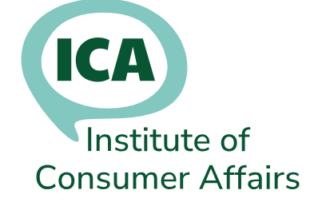
Membership Application
 | Title | Mr/Mrs/Ms/ Other (specify)
 | First Name(s)
 | Surname
 | Please tick the address to be used for correspondence
 | Home address: | Tick one
 | Job title:
 | Employer:
 | Office address: | Tick one
 | Previous employer (if less than a year):
 | Home phone:
 | Office phone:
 | Mobile phone:
 | Please tick the email address to be used for icanews. You can use either or both
 | Home email:
 | Office email:
 | Relevant qualifications or courses attended (specify):
 | Please outline any other relevant details or experience, which may assist us in evaluating your application:
 | How did you hear about ICA? (If a member, please say who):
 | Why do you want to join ICA?
 | Signed: |  |  |  | Date:
Tick if you are paying by BACS |  |  | Sort code: 08-92-99.  Account number: 65208449  Account Name: Institute of Consumer Affairs.  Reference: (Your name)
Tick if you are enclosing a cheque |  |  | Send to: ICA, Corsletts Farm, Church Road, Broadbridge Heath, Horsham, West Sussex, RH12 3LD  Payable to: Institute of Consumer Affairs
If you require an invoice, please provide details, including a Purchase Order number

Conditions for Membership
Membership of the Institute is open to anyone who:
a) is working in consumer affairs, OR
b) is involved in the management of a consumer affairs function at any level, OR
c) is working in consumer education or information, OR
d) is working in enforcement of consumer affairs related legislation, OR
e) works in another organisation whose aims and objectives are acceptable to the Executive, OR
f) has demonstrated support for consumer affairs and continues to support the aims and objectives of the Institute and has proved acceptable to the Executive.
g) is studying for a qualification or apprenticeship linked to consumer affairs
‘Consumer affairs’ is defined as working to protect or promote the interests of consumers, or delivering a compliance or customer service role in a business that trades with consumers.
Type of Membership The membership year runs from 1 September to 31 August.
Full applicants who meet the above criteria.
Unwaged applicants who meet the above criteria and are retired or have no income from employment.
Different application forms are available for the following types of membership:
TIS Training and information Service for multiple applicants in one organisation
Student applicants studying for a career in consumer affairs
The aims of the Institute are:
- To promote and protect the interests of consumers through campaigning, lobbying and consultation with other relevant bodies and individuals.
- To promote good practice in consumer protection provision by encouraging appropriate levels of advice, representation, information, education and enforcement services which reflect the needs of all consumers.
- To influence consumer affairs policy generally, to consider and carry out research on any related matter and including to represent the interests of those consumers facing disadvantage.
- To promote the training and development of members, those starting their career in consumer protection and others in consumer affairs through a programme of training courses provided by the Institute itself or in co-operation with others.
- To ensure and protect the professional status of its members.
Membership Benefits
Free ICA Seminars
Free training /webinars
Membership of icanews – 24 hr online news, advice and information service
Opportunities to contribute to consultation documents on consumer related issues
Voting rights at ICA AGM
For more information, visit our website: www.icanet.org.uk
Or contact Membership Secretary membership@icanet.org.uk

