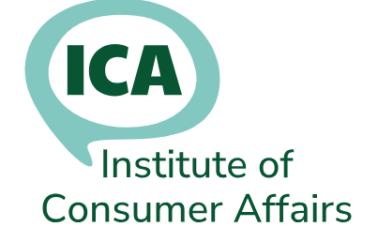
Student Membership Renewal

Please complete this form - even if your details haven’t changed, so we can keep our records up to date.

If you no longer qualify for Student Membership but would like to remain a member, please complete a Membership Application form

Title | Mr/Mrs/Ms/ Other (specify)
First Name(s)
Surname
Please tick the address to be used for correspondence
Home address: |  |  |  | Tick one
Job title:
Employer name and address: |  |  |  | Tick one
Home phone:
Office phone:
Mobile phone:
Please tick the email address to be used for icanews. You can use either or both
Home email:
Office email:
ICA Student Membership is available free of charge whilst you are studying for a qualification or apprenticeship linked to consumer affairs (for a maximum of three years).

Please provide details below of the qualification/apprenticeship you are studying, the name of the training provider and the relevant dates for your training.

Name of qualification/apprenticeship and training provider |  | Start date | End date
For more information, visit our website: www.icanet.org.uk
Or contact Membership Secretary: membership@icanet.org.uk

