TIS Membership Application
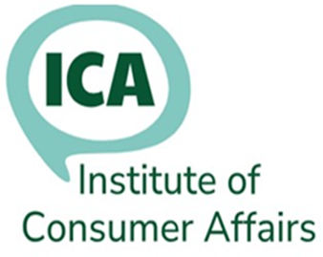

Title | Mr/Mrs/Ms/ Other (specify)
First Name(s)
Surname
Please tick the address to be used for correspondence
Home address: |  |  |  | Tick one
Job title:
Employer:
Office address: |  |  |  | Tick one
Home phone:
Office phone:
Mobile phone:
Please tick the email address to be used for icanews. You can use either or both
Home email:
Office email:
Please outline any relevant qualifications or experience, which may assist us in evaluating your application:

Why do you want to join the ICA?
Signed: |  |  | Date:
TIS membership subscriptions are paid by your employer
If you have any questions, please contact: |  | Membership Secretary, membership@icanet.org.uk
This form is for more than 5 applicants at the same organisation. Each applicant should complete a form.

Conditions for Membership
Membership of the Institute is open to anyone who:
a) is working in consumer affairs, OR
b) is involved in the management of a consumer affairs function at any level, OR
c) is working in consumer education or information, OR
d) is working in enforcement of consumer affairs related legislation, OR
e) works in another organisation whose aims and objectives are acceptable to the Executive, OR
f) has demonstrated support for consumer affairs and continues to support the aims and objectives of the Institute and has proved acceptable to the Executive.
g) is studying for a qualification or apprenticeship linked to consumer affairs
‘Consumer affairs’ is defined as working to protect or promote the interests of consumers, or delivering a compliance or customer service role in a business that trades with consumers.
Type of Membership The membership year runs from 1 September to 31 August.
Full applicants who meet the above criteria.
Unwaged applicants who meet the above criteria and are retired or have no income from employment.
TIS Training and information Service for multiple applicants in one organisation
A different application form is available for Students/apprentices for whom membership is free:
Student applicants studying for a career in consumer affairs
The aims of the Institute are:
- To promote and protect the interests of consumers through campaigning, lobbying and consultation with other relevant bodies and individuals.
- To promote good practice in consumer protection provision by encouraging appropriate levels of advice, representation, information, education and enforcement services which reflect the needs of all consumers.
- To influence consumer affairs policy generally, to consider and carry out research on any related matter and including to represent the interests of those consumers facing disadvantage.
- To promote the training and development of members, those starting their career in consumer protection and others in consumer affairs through a programme of training courses provided by the Institute itself or in co-operation with others.
- To ensure and protect the professional status of its members.
Membership Benefits
Free ICA Seminars
Free training /webinars
Membership of icanews – 24 hr online news, advice and information service
Opportunities to contribute to consultation documents on consumer related issues
Voting rights at ICA AGM
For more information, visit our website: www.icanet.org.uk
Or contact Membership Secretary

