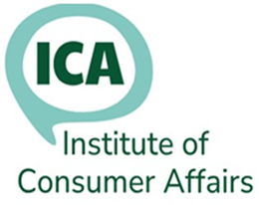
ICA Training and Information Service
Annual Subscription Renewal

This form is only for Multiple members at one organisation. Please complete all of the form so we can keep our records up to date.

Employer’s details for invoicing
Your order date: |  | Your order No:
Contact Name: |  |  |  | Phone No:
Contact email:
Organisation Name and Address for invoice:
Total number of Members to be invoiced:
Please list all members and email addresses on the next page. If there have been staff changes, you may substitute another person and provide the details on the second table.

Please return the completed form to:
membership@icanet.org.uk

1. The membership year runs from 1 September to 31 August.

2. Members who joined after 1 June, do not have to pay a renewal fee the following September.

3. Annual membership fees are: £25 each for the first 5 members, £20 for each additional member.

4.There is no fee for students/apprentices.

Payment: Sort code: 08-92-99
Account number: 65208449
Account Name: Institute of Consumer Affairs.
Reference: (Your name and invoice number)

For membership enquiries, contact: Membership Secretary
Email: membership@icanet.org.uk

For finance enquiries, contact: ICA Treasurer
Email: finance@icanet.org.uk

Institute of Consumer Affairs

List of all current Members
Member’s full name | Email | Substitution  Yes/no

Substitutions Details
New Member’s name | Email | Previous member’s name

